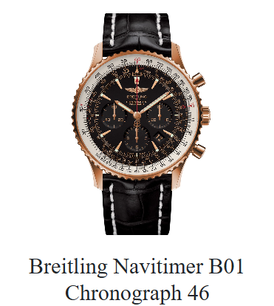

**🕰️ Product Name:** Breitling Navitimer B01 Chronograph 46

**Description:**  
The Breitling Navitimer B01 Chronograph 46 is a distinguished pilot's watch that marries classic aviation design with modern horological advancements. Featuring the in-house Breitling 01 movement, this timepiece offers precision, a 70-hour power reserve, and the iconic circular slide rule bezel for flight calculations.

**Specifications:**

* **Movement:** Breitling 01 (Manufacture), self-winding mechanical
* **Power Reserve:** Approximately 70 hours
* **Chronograph:** 1/4th second, 30 minutes, 12 hours
* **Case Material:** Stainless steel
* **Case Diameter:** 46 mm
* **Case Thickness:** 13.95 mm
* **Water Resistance:** 3 bars (30 meters)
* **Crystal:** Cambered sapphire, glareproofed both sides
* **Bezel:** Bidirectional, slide rule
* **Dial Options:** Various, including black, blue, green, and copper
* **Strap Options:** Alligator leather or stainless steel bracelet
* **Weight:** Approximately 114 g (without strap)

**Price:**

* **Retail Price:** $9,900 USD